**Quiet time**….. **DEEP LISTENING**

Move my attention to that deep inner place…

* Where my inner voice [yes, God’s voice] seeks to be heard
* Where my most profound questions take shape



[This Photo](https://onewomanseye.blogspot.com/2012/08/think-before-you-speak-or-tweet-or.html) by Unknown Author is licensed under [CC BY-NC-ND](https://creativecommons.org/licenses/by-nc-nd/3.0/)

* Where the spark of my heart gives new energy
* Where the challenges and struggles seek resolve
* Where inner silence invites me to deep listening
* Where creative images emerge from the chaos and darkness

**DEALING WITH DISTRACTIONS….**

* **Notice where my focus is going… AKA ”distraction”**
* **What is the significance of the content….**

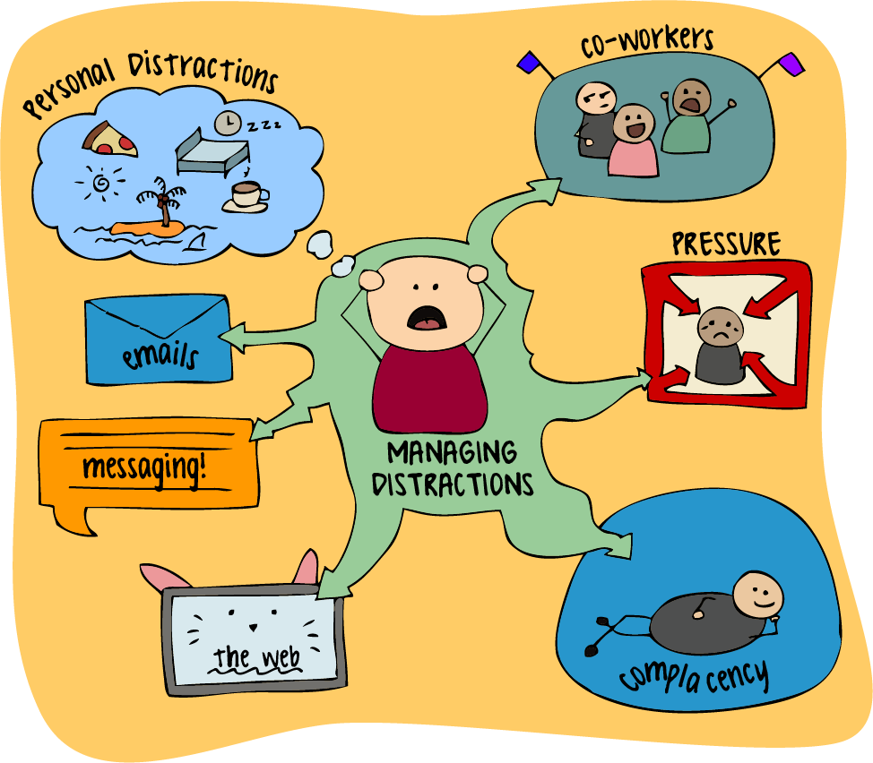

[This Photo](https://ccmit.mit.edu/observation/) by Unknown Author is licensed under [CC BY](https://creativecommons.org/licenses/by/3.0/)

* An invitation from God to pay attention
* A self-pre-occupation --- for later
* A fear or worry – Address/present to Jesus, Mary, spiritual director, etc.
* A concern, fear or worry that can be attended to after the retreat
* **Ways to respond:**
* Journal with the distraction… interview “it” [have a conversation with it], analyze it and then take it to prayer
* Come to realization that the “distraction” will “pop up” and you do have the ability to put it aside/ control it / deal with it at another time / entrust “it” to God, your guardian angel, etc.
* Name “it” and promise to “deal” with “it” at another time [maybe after the retreat]
* Incorporate the distraction into your prayer…pondering it with “Jesus, the Holy Spirit, companion saint, spiritual director/companion, etc.
* Sing it, dance it, draw it….give it a name and a place to keep it! [to re-visit another time]
* Dismiss it…say “good-bye”
* AND, what else might work for YOU!